MangaUpdates

Definition
# Source: ScreenShots Source: Provided by: [Persons Table -> ID Column: 1, Name_En Column: Motasem Essam] -> Tool: [Lightshot Program] -> From [Site: https://www.mangaupdates.com] on [10/29/2025]
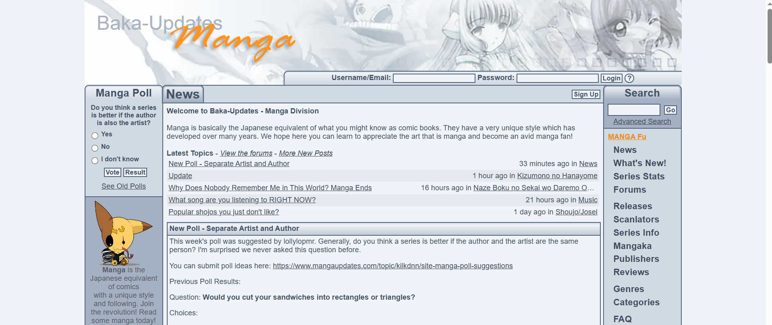
# Source: AI Source: Provided by: [Data Path: Persons Table -> ID Column: 1, Name_En Column: Motasem Essam] -> From: [ChatGPT] on [10/29/2025]
MangaUpdates (also called Baka-Updates Manga) is a comprehensive manga database and tracking site, especially focused on scanlations and fan translations.
- Website: https://www.mangaupdates.com
- Purpose: Catalog manga, provide release info, and track ongoing series.
- Focus: Both official releases and fan-translated content.

Key Features
# Source: AI Source: Provided by: [Data Path: Persons Table -> ID Column: 1, Name_En Column: Motasem Essam] -> From: [ChatGPT] on [10/29/2025]
a) Manga Database
- Contains thousands of manga series from Japan, Korea, China, and other countries.
- Detailed info for each series:
  - Title (English, original, synonyms)
  - Author & artist
  - Publisher (if official)
  - Genres (shonen, seinen, romance, action, etc.)
  - Status (ongoing, completed, hiatus)
  - Number of volumes and chapters
  - Release dates for both official and scanlated chapters
b) Volumes & Chapters
- Lists all volumes of a manga series, often with:
  - Cover images (official when available)
  - Volume release dates
  - Chapters included in each volume
- Great for tracking which chapters are in which volumes.
c) Scanlation Info
- Tracks fan translation groups and their release updates.
- Shows which chapters are scanlated, released, or missing.
d) User Interaction
- Users can comment on series or chapters.
- Ratings and reviews are available.
- Users can maintain personal manga tracking lists.
e) Community & Extras
- News and updates about manga releases.
- Sometimes links to official or fan resources.

Usage
# Source: AI Source: Provided by: [Data Path: Persons Table -> ID Column: 1, Name_En Column: Motasem Essam] -> From: [ChatGPT] on [10/29/2025]
- For collectors: Check volume lists, cover images, and release dates.
- For readers: Track which chapters are translated or scanlated.
- For researchers or enthusiasts: Find detailed series metadata, author info, and release history.

Summary
# Source: AI Source: Provided by: [Data Path: Persons Table -> ID Column: 1, Name_En Column: Motasem Essam] -> From: [ChatGPT] on [10/29/2025]
MangaUpdates is a detailed reference site for manga fans, especially useful for:
- Tracking volumes and chapters
- Viewing cover images
- Following scanlation groups and fan translations
- Checking official and fan release info

